

**Diploma in Computing (with strands in Software Development & Computer Networks)**

**Level 7**

**(Software Development Strand)**

**DC304 Object-Oriented Analysis and Design**

**Construction Site Attendance Application project**

|  |  |
| --- | --- |
| Liana Pak | yib000013o |
| Omid Ardakani | Yib00001kq |
| Sviatlana Belabarodava | yib00001yl |

**Table of Content**

1. Introduction and overview of the project 3

1.1 Introduction 3

1.2 Business Context 3

1.3 Project Description 3

1.4 Goal and objectives of the project 3

1.5 Development Methodology 3

1.6 The target audience and benefit of the information system 3

2. System Requirement Specifications 5

2.1 Functional requirements 5

2.2 Non-functional Requirements 5

3. Functional Model 5

3.1 Use case diagram 5

3.2 Use case specifications 6

3.3 Activity diagrams 8

4. Object Model 10

4.1 Class diagram with attributes and operations 10

4.2 Object diagram 11

5. Logical Design Model 12

5.1 Sequence diagrams 12

5.2 State machine diagrams 18

5.3 Communication diagrams 19

6. Project Marking Criteria 22

7. References 25

# Introduction and overview of the project

## Introduction

Company W is a New Zealand construction organization that is based in Auckland. It constantly has several objects under construction called projects and each of these projects has one or several sites. Employees are daily assigned to the sites depending on their specialization and qualification. Site managers have to track and approve workers’ working hours on a daily basis. After that Project Managers can reject or approve the Timesheet.

## Business Context

The company W is facing a problem of processing all the information described above using paper work. Documentation process includes:

* Attendance form printing out and filling in
* Approval by Site Manager with sending papers by post to the office
* Final Approval by Project Manager

All these issues lead to postpones in salary payment.

## Project Description

## Goal and objectives of the project

## Project Goal

## The main goal of project is to decrease time spent for processing timesheets.

## Project Objective

## To provide a central system for tracking timesheets of workers in construction projects.

## Development Methodology

For handling that task was chosen a team consisting of 3 people and 9 weeks to finish the project. As the team is not big and the timeframe is short, there was chosen an Incremental Model which is used when requirements are clearly defined and understood, and there’s a need for early withdrawal of the product to the market.

For handling that task was chosen a team consisting of 3 people and 9 weeks to finish the project. As the team is not big and the timeframe is short, there was chosen Kanban methodology as an agile Incremental model which is used when requirements are clearly defined and understood, and there’s a need for early withdrawal of the product to the market.

We organize our work on a Kanban board. The board has states as columns, which every work item passes through – from left to right. We pull our work items along through the “To do”, “In Progress”, “Testing” and “done” columns. The only management criteria introduced by Kanban is the so called “Work In Progress (WIP)”. By visualizing work on a Kanban board and monitoring WIP we could optimize flow of work and manage the project.

we have used Trello for online kanban board and Git hub as source control for improve team collaboratin and manage changes and control versions

Here is the list of the diagrams and documentation that the team was using during the design period:

* Use case diagrams
* Use case specifications
* Activity diagrams
* Class diagram
* Object diagram
* Sequence diagrams
* State machine diagrams
* Communication diagrams

## The target audience and benefit of the information system

# System Requirement Specifications

## Functional requirements

The company W wants to have an automated system with the following functional requirements:

* An application realizes a multi-level management of attendance
* Keep information about site and project hierarchy
* Keep general information about workers and daily worked hours.

All functional requirements we will divide to Process Oriented and Information Oriented requirements.

Process Oriented requirements are following:

* Admin has possibility to create/update/delete Users, Sites, Projects
* Site Manager can create / update / approve time records
* Project Manager can approve/reject timesheet

Information Oriented requirements are following:

* For **time record** following information should be kept:   
  ID of worker who did a job,   
  Date on which the job was done   
  ID of Site at which job was done   
  Working hours which were worked during the day  
  Status: status for time record shows whether this record was created and saved, or it is approved by Site and Project Manager.
* For **Site:**Site name   
  Site address   
  ID of manager of the site   
  ID of project, to which this site belongs
* For **Project**name of the project

Address of the project   
ID of manager

* For **employee**Name   
  Surname   
  Contact information  
  Role: role of employee means a position of employee, it can be Admin, worker, Site Manager, Project Manager.

## 2.2 Non-functional Requirements

During our communication with the customer representatives, our company had found out that W also needs an application that can (non-functional requirements):

* Handle at least 6 projects with 6 sites and 50 workers
* Be available 24/7
* Have a user friendly and simple UI.

# Functional Model

# Use case diagram

The diagram displays the interactions of users and system

A close up of a map

Description generated with high confidence

# Use case specifications

These specifications are formed to capture the users’ fundamental needs within the system. They are formed based on Use case diagram for capturing functional requirements of the system.

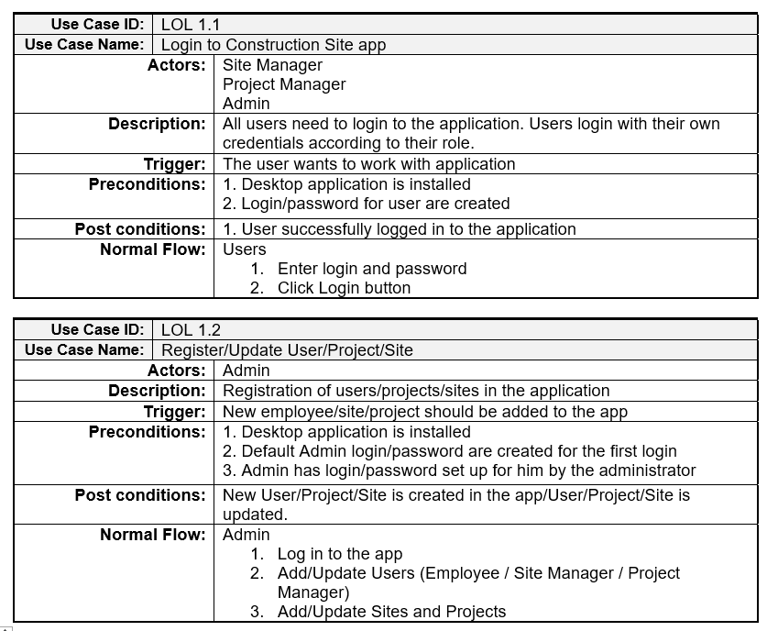

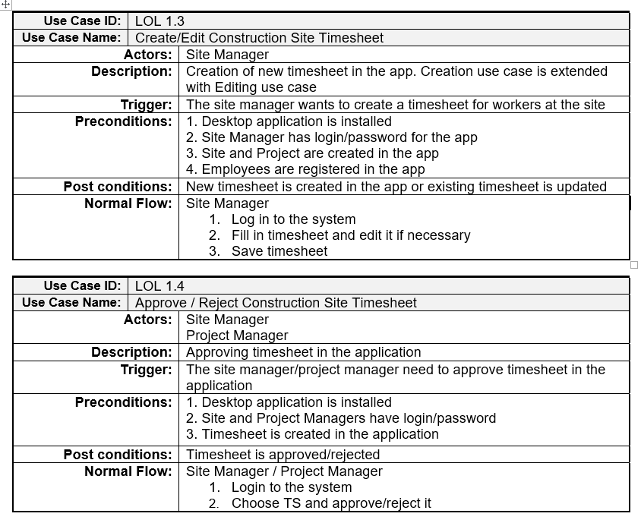

# Activity diagrams

These diagrams are showing the dynamic nature of the system by passing messages and showing the user different options to act.

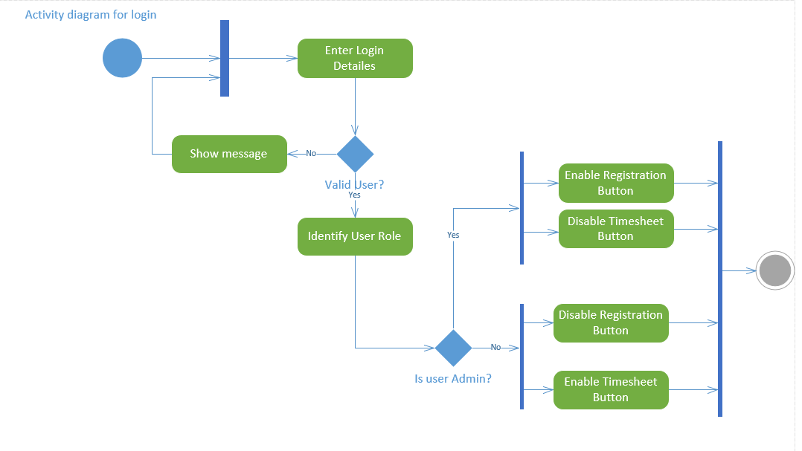

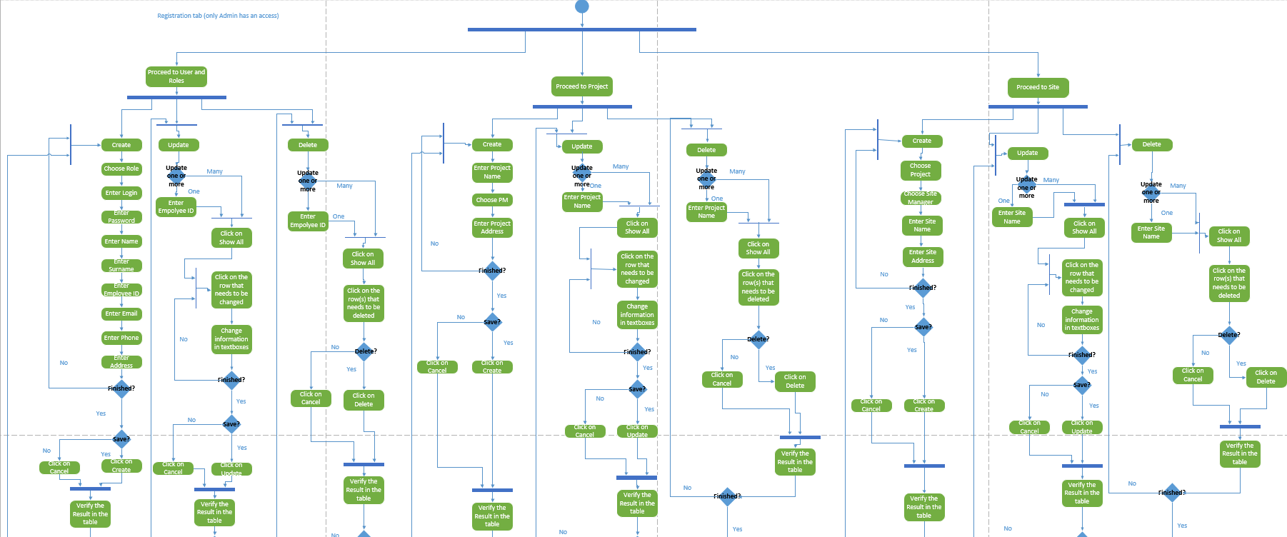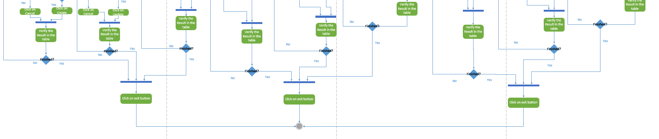

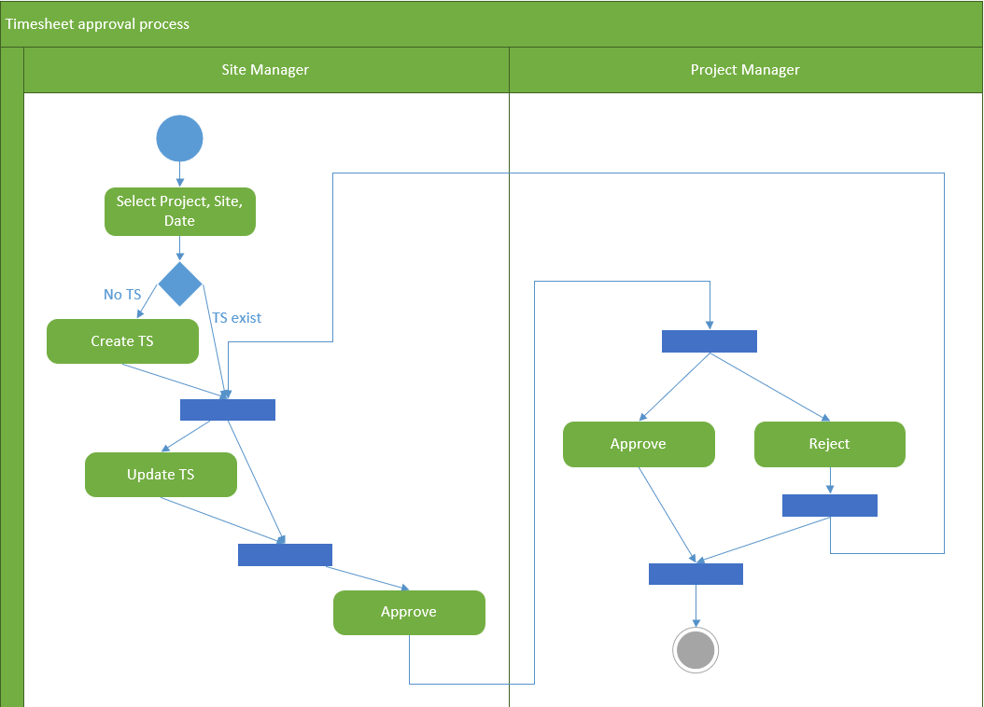

# Object Model

# Class diagram with attributes and operations

Class diagram is used for modelling the system for further coding, understanding the classes, attributes, methods and their interconnection.

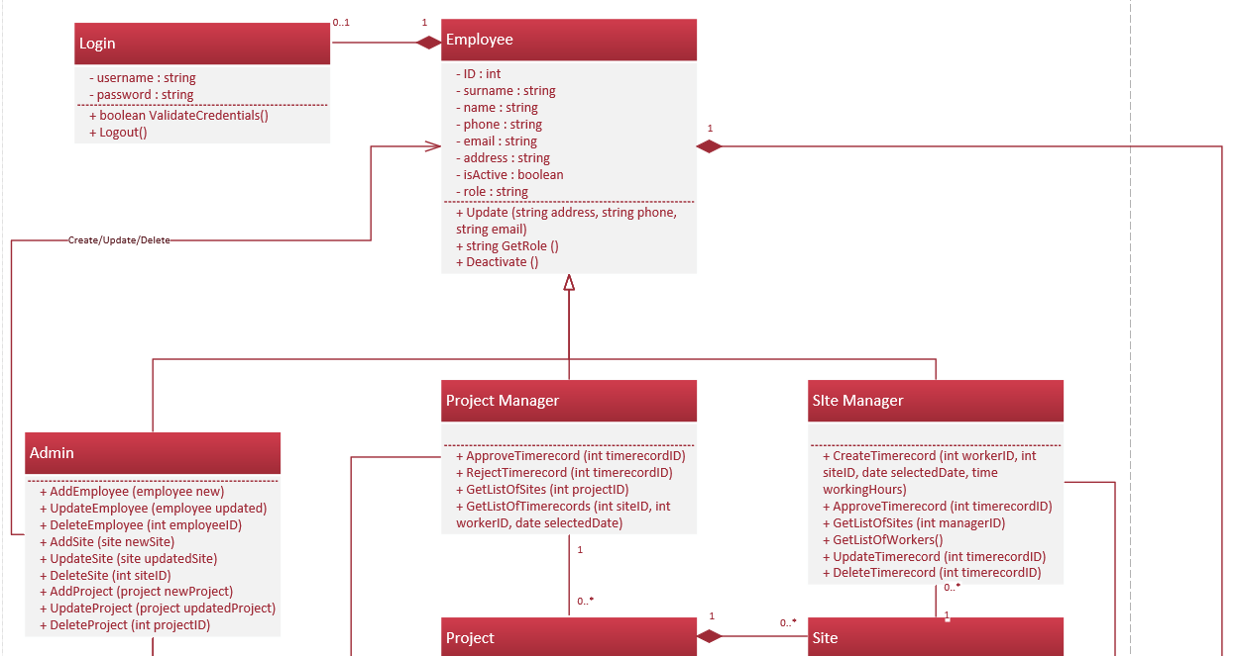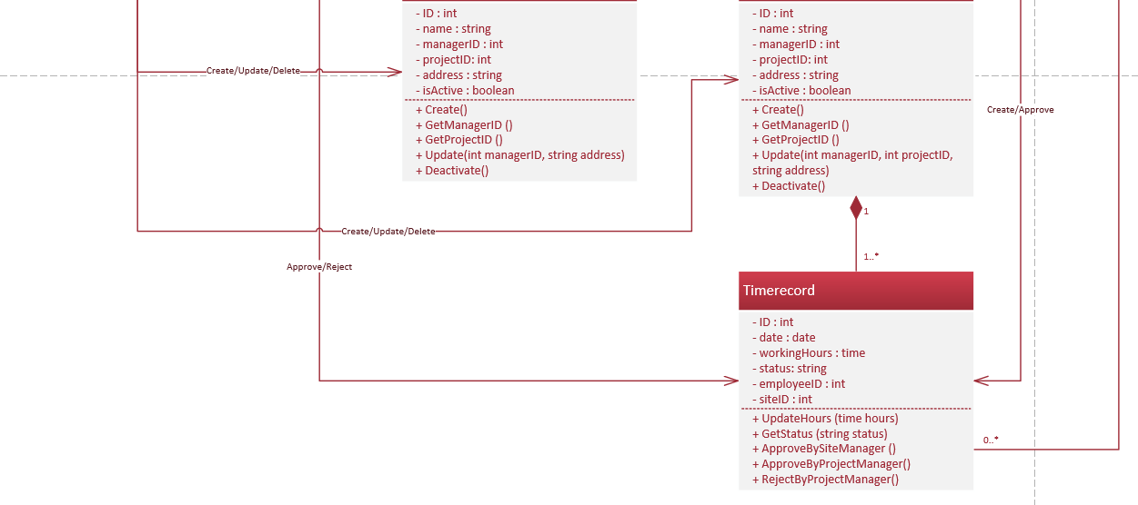

# Object diagram

The diagram is used for modelling the system for further coding, understanding the objects and their interconnection.

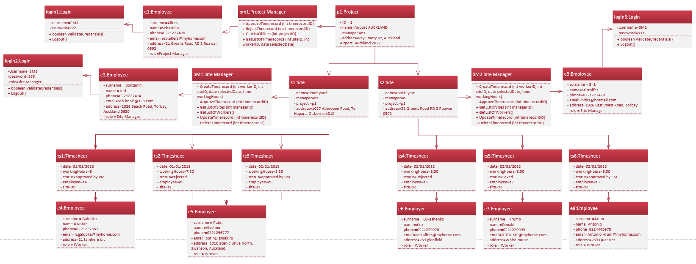

# Logical Design Model

# Sequence diagrams

This type of diagram is showing how the objects interact in time sequence.

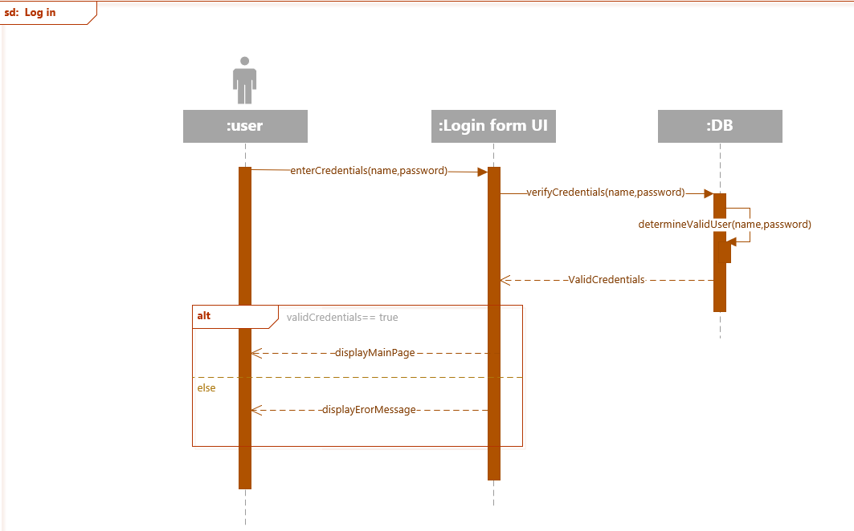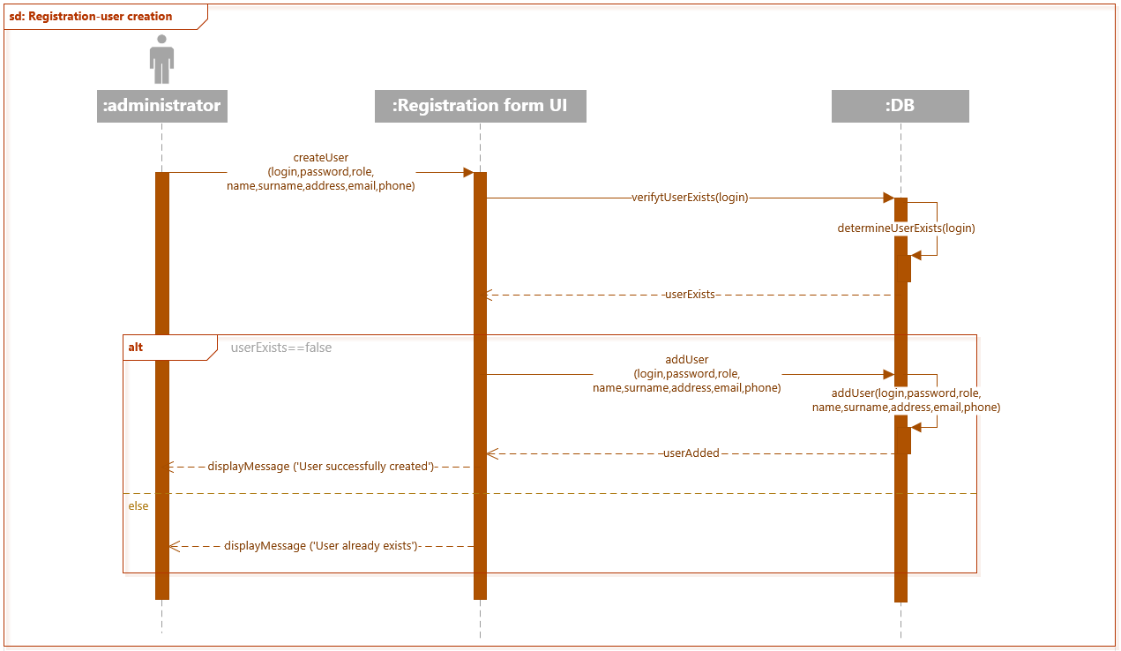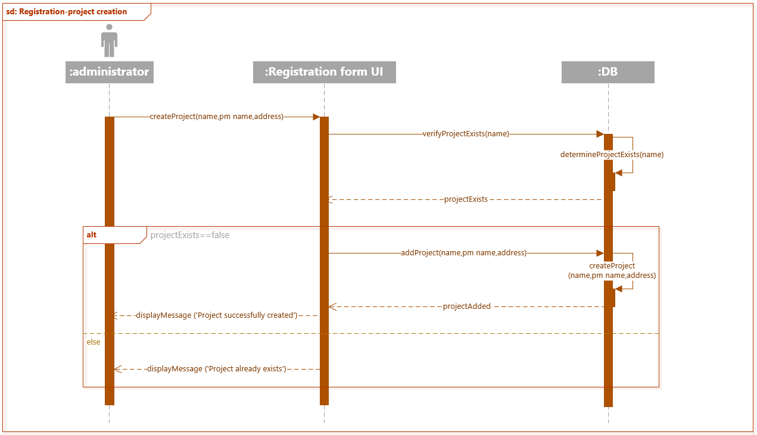

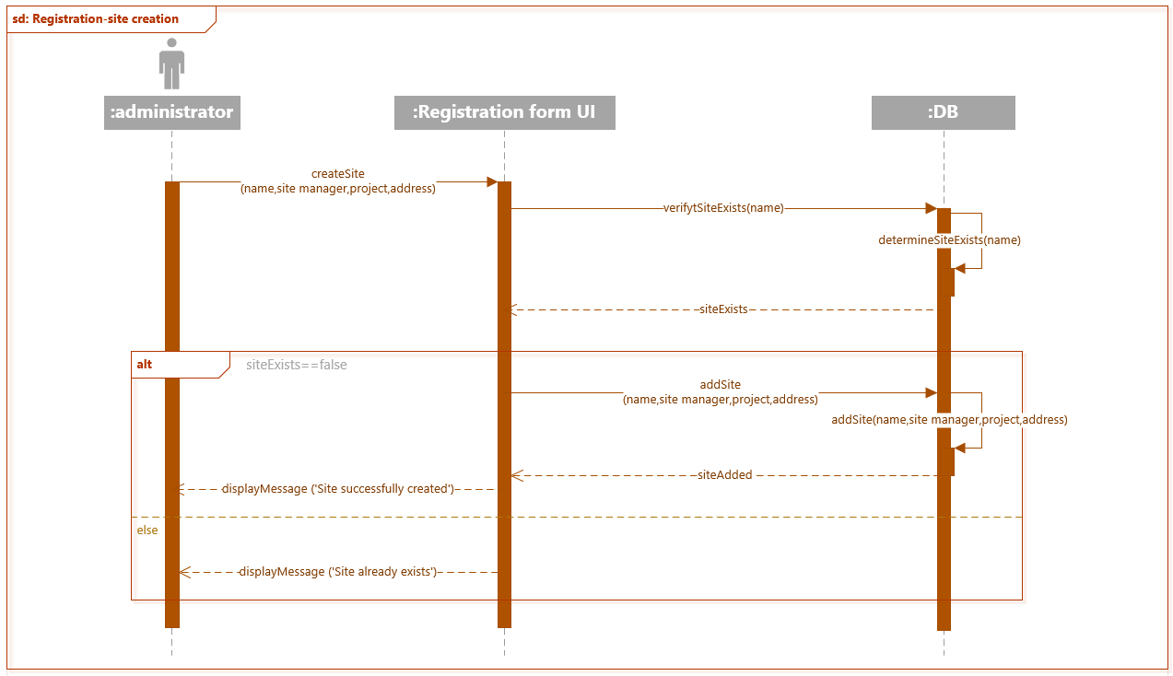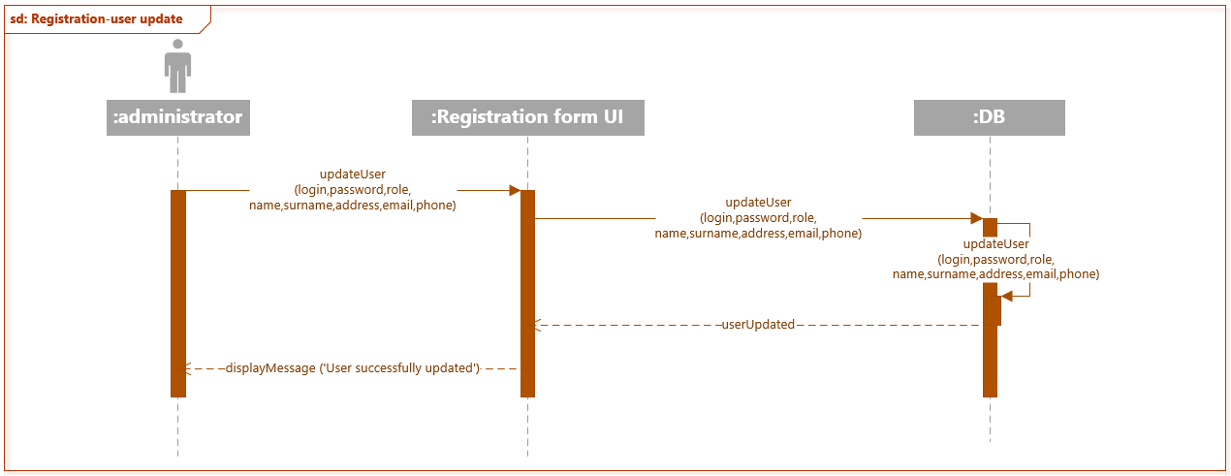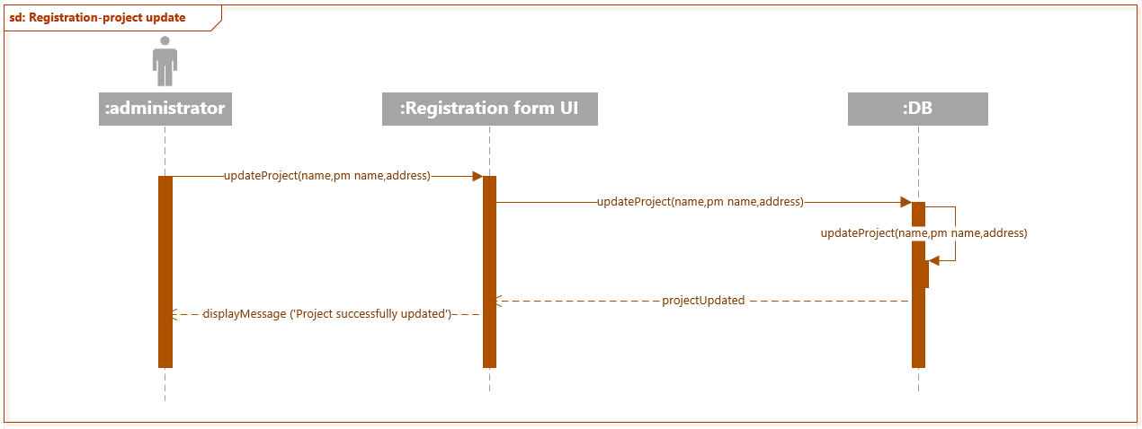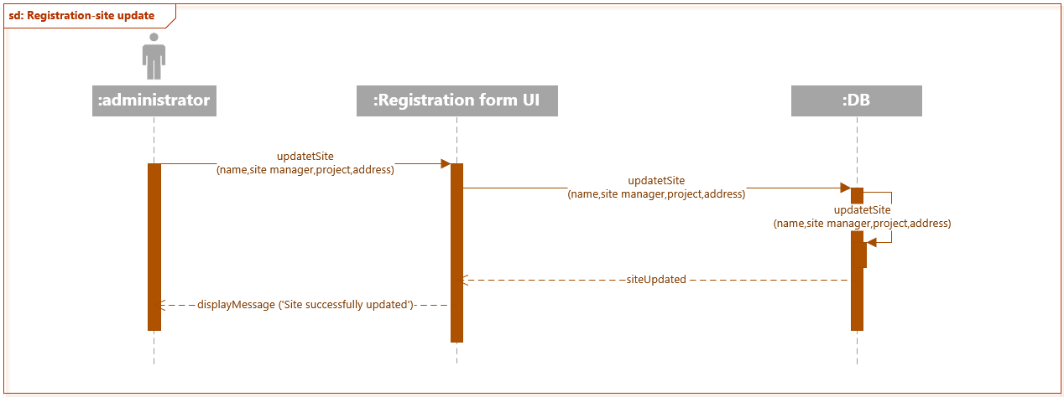

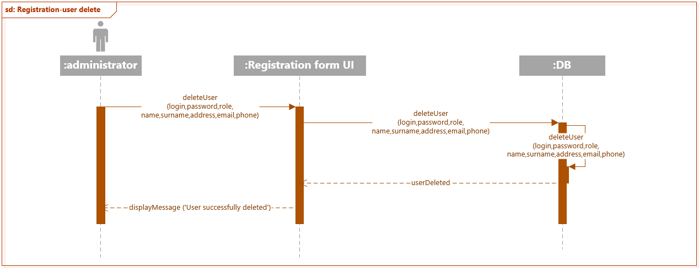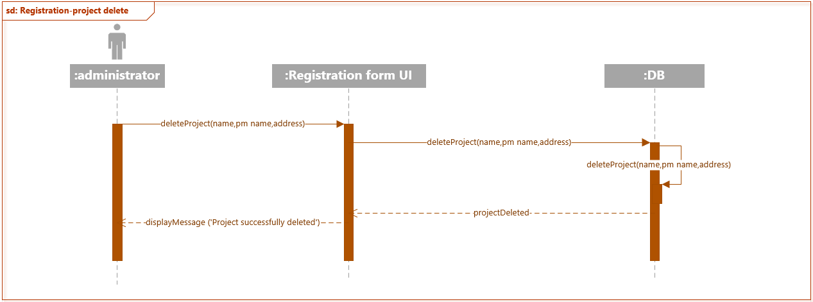

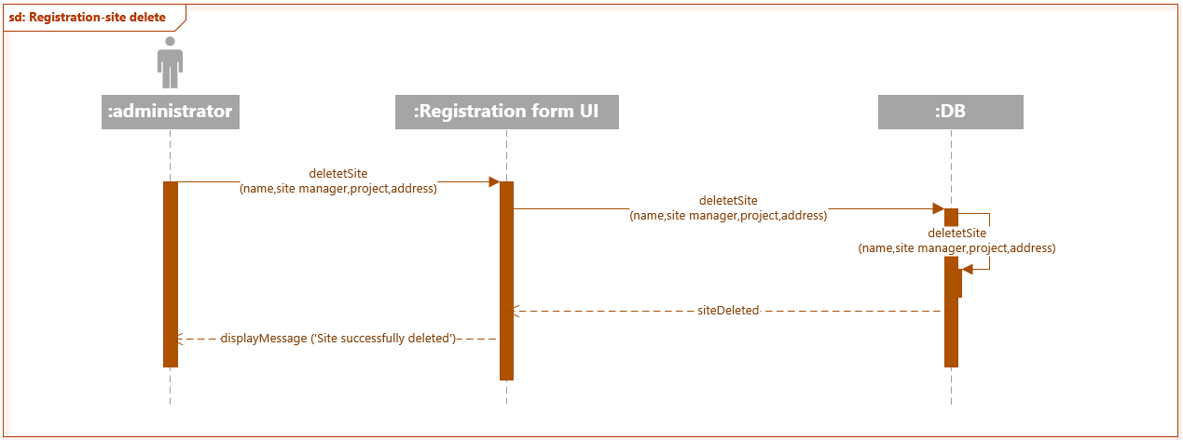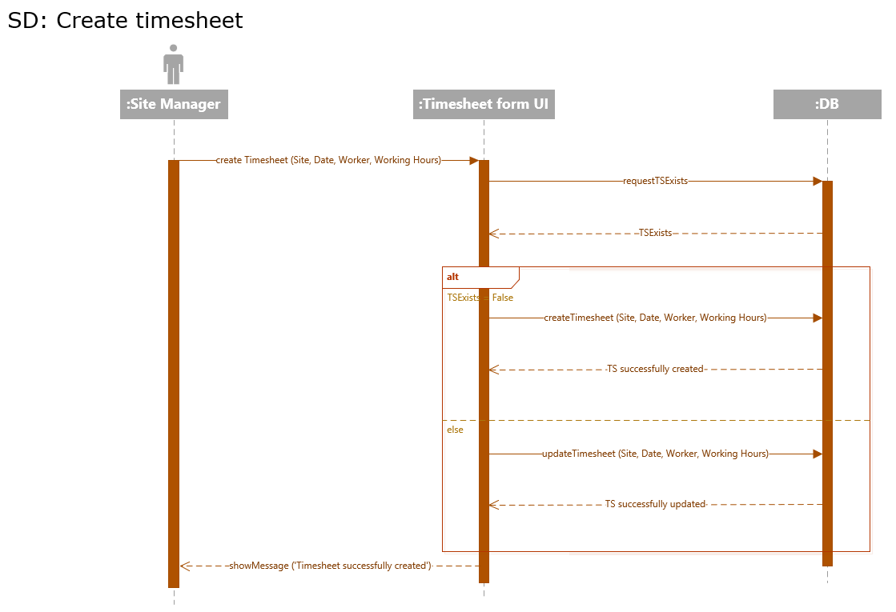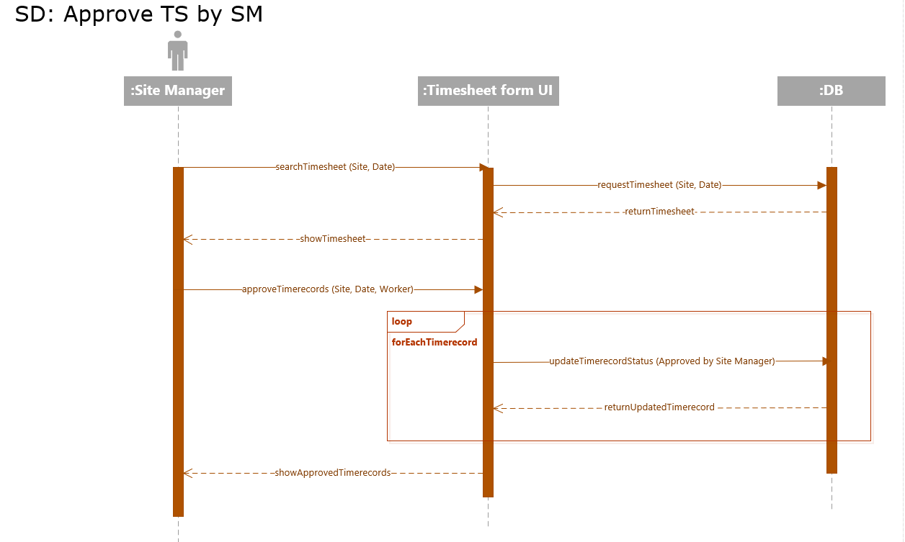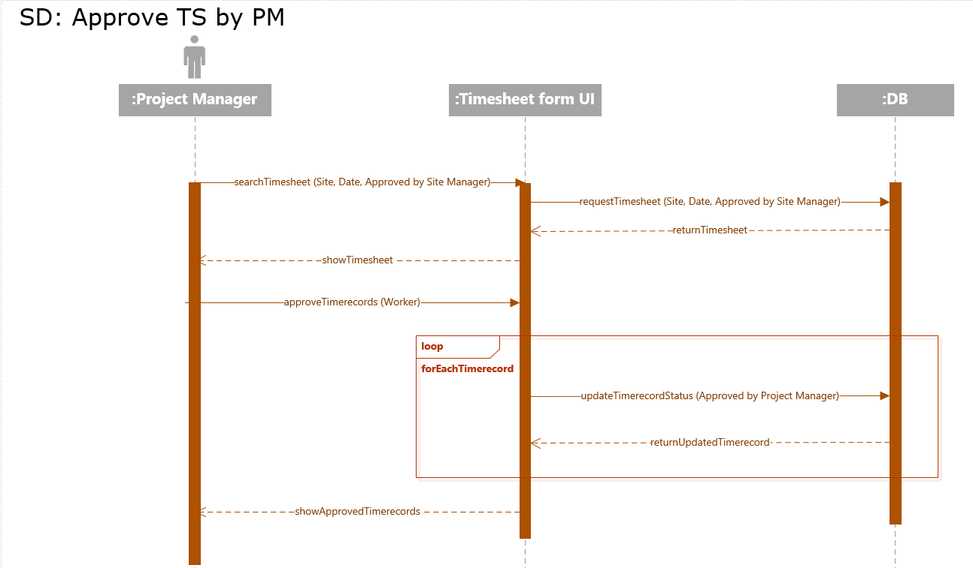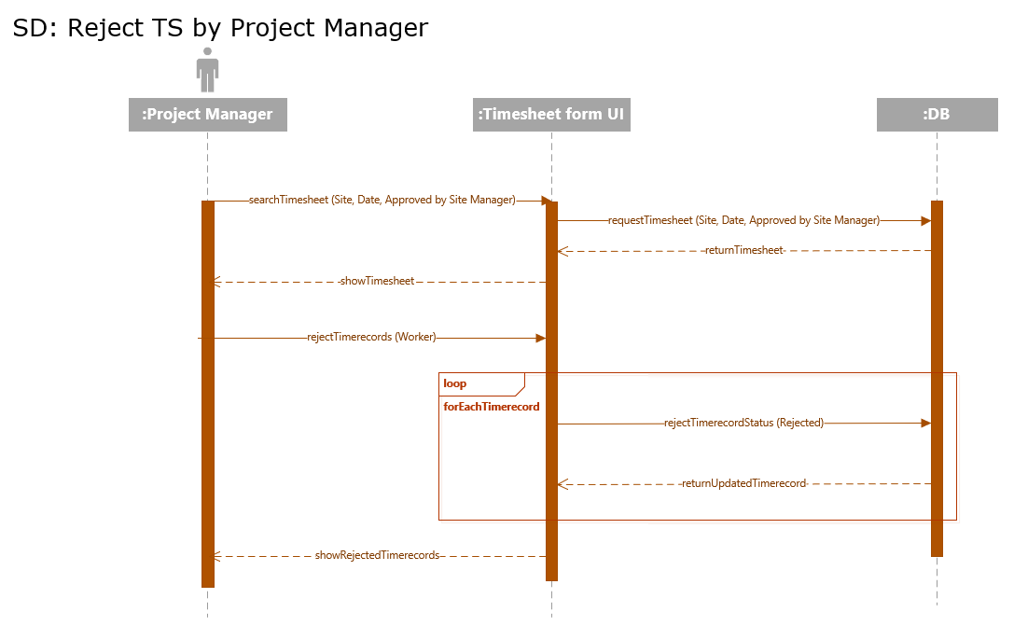

# State machine diagrams

The diagrams are showing different variations of events that an object goes through.

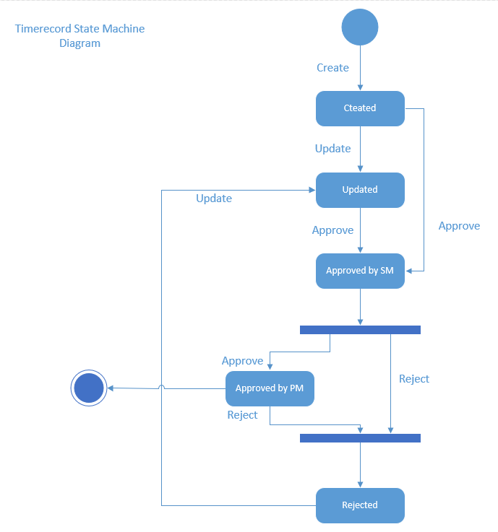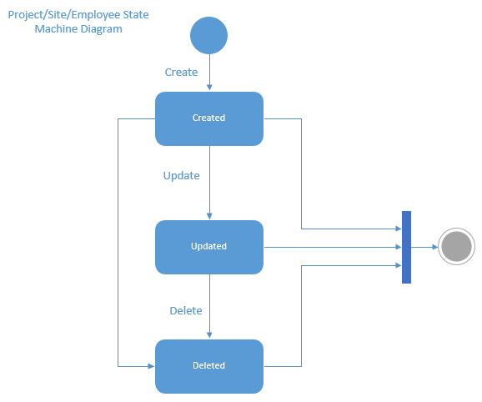

# Communication diagrams

The diagrams show interactions between objects. It helps to create alternative scenarios of interactions if needed.

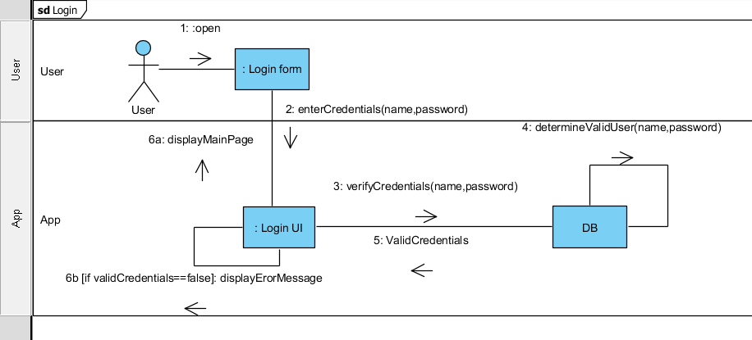

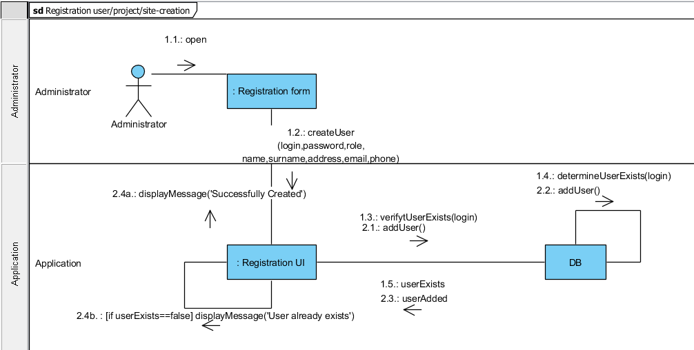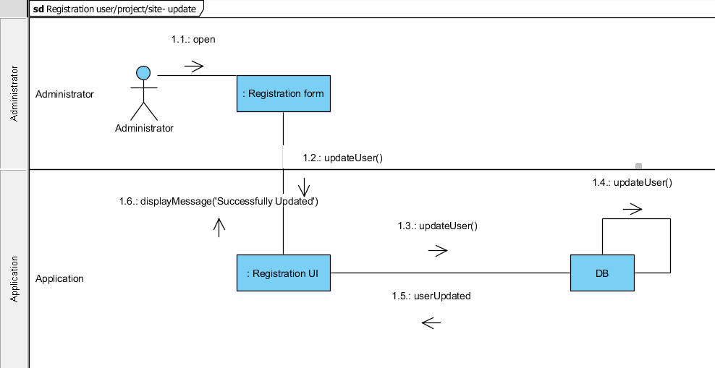

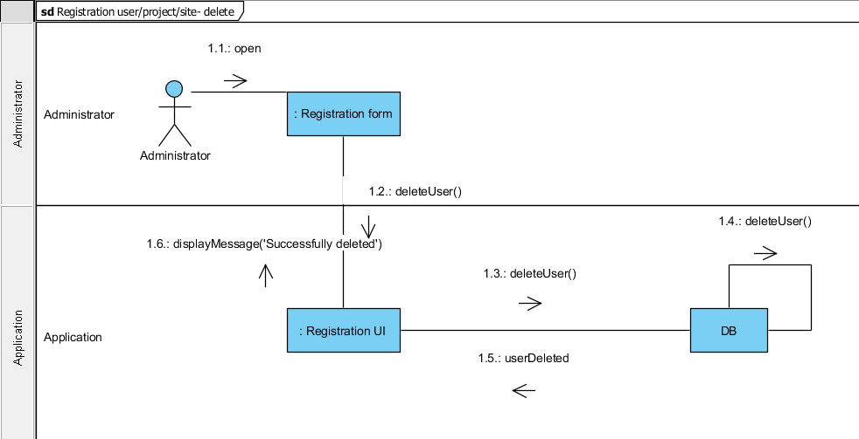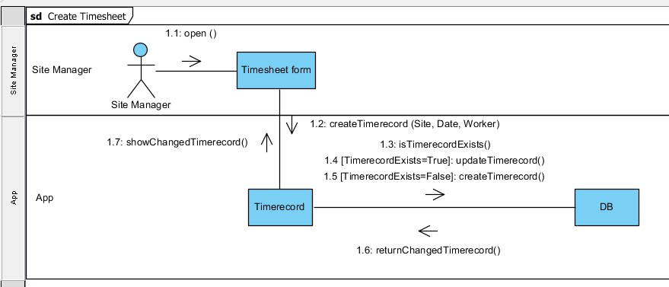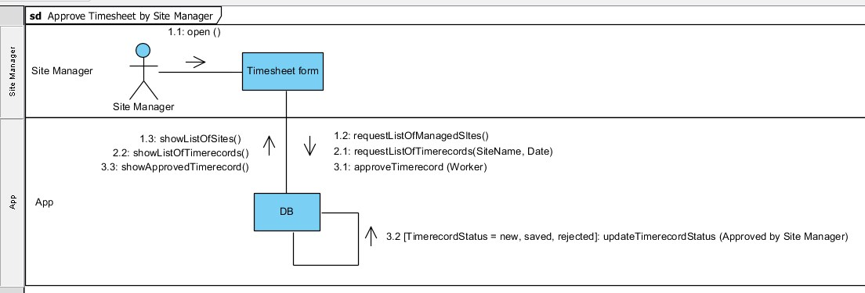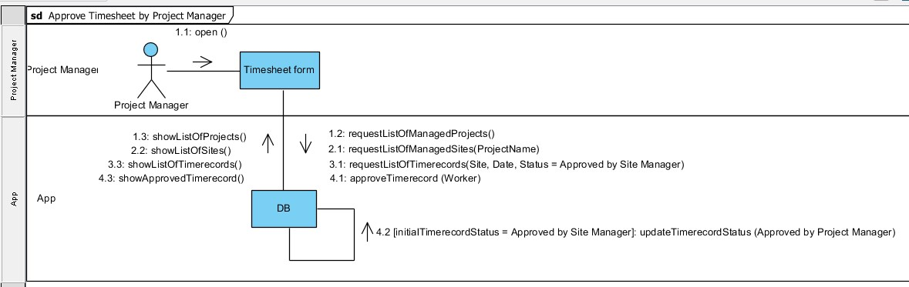

# Project Marking Criteria

|  |  |  |  |
| --- | --- | --- | --- |
| **Marking Criteria** |  |  | **Comment(s):** |
| **Task 1: Introduction and overview of the project** |  |  |  |
| * Introduction * Discussion of the Business Context   + *The business problem is correctly identified* * Project Description   + *A brief description of the project idea and importance and the proposed functions that will be provided by the project.* * Goal and objectives of the project   + *The project’s main goals and objectives have been identified.* * Development Methodology which will be adopted   + *The development methodology to be used have been identified*   + *The motivations behind selecting this methodology have been described*   + *The development methodology steps have been clearly explained* * The target audience and benefit of the information system o *The targeted people that will get benefited from the project have been identified*    + *The benefits of the project have been described*   *(tangible and intangible)* | 1    2    2        2        1    2    2        1    2 |  |  |
| ***Total>>>*** | 15 |  |  |
|  |  |  |  |
| **Task 2: System Requirements Specification** |  |  |  |
| Functional Requirements   * The functional requirements are clearly identified and summarised precisely. * They have been classified as Process Oriented or Information Oriented requirements. | 4      3 |  |  |
| Non Functional Requirements   * The non-functional requirements are clearly identified and summarised precisely. * They have been classified as Operational, Performance, Security or Cultural and Legal requirements. | 4        4 |  |  |
| ***Total>>>*** | 15 |  |  |

|  |  |  |  |
| --- | --- | --- | --- |
|  |  |  |  |
| **Task 3: Functional Model** |  |  |  |
| Use case Diagrams   * The use case diagram should capture all the system functionalities in scope and actors. * *The diagrams analyse the required system correctly* * *The diagrams use correct UML 2.0 notation* | 4    2  2 |  |  |
| Use case Specification   * A specification has been given for each use case * Each specification includes the main sections (use case name, actors, preconditions, post conditions, steps). | 3    3 |  |  |
| Activity Diagram   * Capture all functionality in use cases * *The diagrams use correct UML 2.0 notation* | 3  3 |  |  |
| ***Total>>>*** | 20 |  |  |
|  |  |  |  |
| **Task 4: Object Model** |  |  |  |
| Class Diagrams   * Correct classes have been identified * Attributes and operations are identified for each class * Appropriate relationships are used (Association, multiplicity, generalization) * *The diagrams use correct UML 2.0 notation* | 3  3  3    1 |  |  |
| Object diagrams   * The diagrams are consistent with the class diagram. * *The diagrams use correct UML 2.0 notation.* | 4  1 |  |  |
| ***Total>>>*** | 15 |  |  |
|  |  |  |  |
| **Task 5: Logical Design Model** |  |  |  |
| Sequence Diagrams   * The diagrams are consistent with the use case diagram. * *Capture all possible scenarios identified in use cases* * *The diagrams use correct UML 2.0 notation* | 4    4  1 |  |  |
| State Machines   * The diagrams are consistent with the class diagram. * Capture the states of each class. * *The diagrams use correct UML 2.0 notation* | 3  3  1 |  |  |
| Communication Diagrams   * The diagrams are consistent with the use case diagram and sequence diagrams. * *Capture all possible scenarios identified in use cases*  *The diagrams use correct UML 2.0 notation* | 4    4  1 |  |  |
| ***Total>>>*** | 25 |  |  |
|  |  |  |  |
| **Task 6: Documentation (10 marks)** |  |  |  |
| * The report includes all the required sections: o Cover page o Table of Content   + Introduction and Overview of the project   + Requirement Specification o Functional Model o Object Model o Logical Design Model   + Discussion: briefly describes any lessons learnt during the analysis and design process.   + References: o Appendices (if any)   + Marking Criteria      * *The report is presented to a professional standard with correct language and grammar is used*      * Discussion Section: *includes appropriate lessons learnt with examples*      * *References:* APA referencing style is used correctly | 2                                    2      3      3 |  |  |
| ***Total>>>*** | **10** |  |  |
| **Overall Mark>>>** | **100** |  |  |

# References

Agile Alliance (n.d.) *Kanban.* Retrieved from: https://www.agilealliance.org/glossary/kanban/#q=~(filters~(postType~(~'page~'post~'aa_book~'aa_event_session~'aa_experience_report~'aa_glossary~'aa_research_paper~'aa_video)~tags~(~'kanban))~searchTerm~'~sort~false~sortDirection~'asc~page~1)

[Association of Modern Technologies Professionals](http://www.amtp.am/). (2018). *Software Development Methodologies.* Retrieved from: http://www.itinfo.am/eng/software-development-methodologies/

Bell D. (2004). *The class diagram.* Retrieved from: https://www.ibm.com/developerworks/rational/library/content/RationalEdge/sep04/bell/

IBM knowledge center. (n.d.) *Directed association relationships.* Retrieved from: https://www.ibm.com/support/knowledgecenter/SS8PJ7_9.1.0/com.ibm.xtools.modeler.doc/topics/cdirasn.html

IBM Knowledge center. (n.d.) *Use-case specification outline* Retrieved from: https://www.ibm.com/support/knowledgecenter/en/SSYMRC_4.0.5/com.ibm.rational.rrm.help.doc/topics/r_uc_spec_outline.htmlrational.rrm.help.doc/topics/r_uc_spec_outline.html

National Technology Institute, (2014). *DC304N Object-Oriented Analysis and Design*.

Visual Paradigm. (n.d.) *What is Activity Diagram?* Retrieved from: https://www.visual-paradigm.com/guide/uml-unified-modeling-language/what-is-activity-diagram/

Visual Paradigm. (n.d.) *What is Communication Diagram?* Retrieved from: https://www.visual-paradigm.com/guide/uml-unified-modeling-language/what-is-communication-diagram/

Visual Paradigm. (n.d.) *What is Sequence Diagram?* Retrieved from: https://www.visual-paradigm.com/guide/uml-unified-modeling-language/what-is-sequence-diagram/